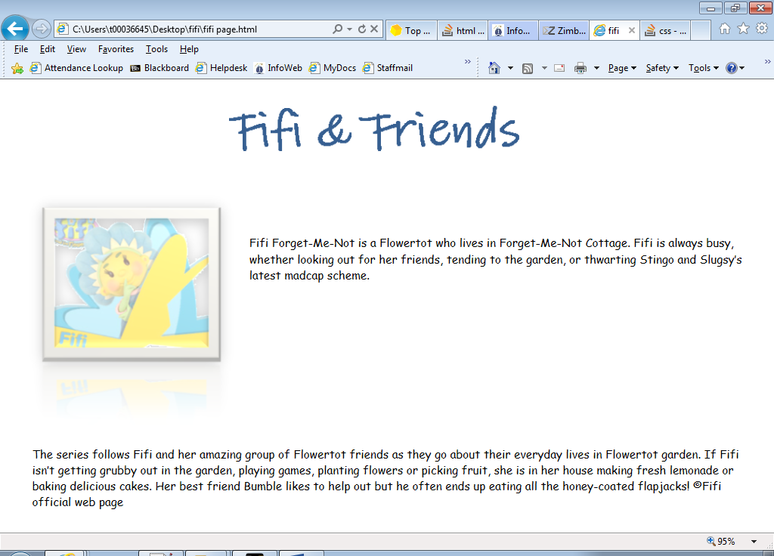

font-family:"comic sans ms";

font-size:16px;

Note the opacity of the left image

Fifi Forget-Me-Not is a Flowertot who lives in Forget-Me-Not Cottage. Fifi is

always busy, whether looking out for her friends,

tending to the garden, or thwarting Stingo and Slugsy’s latest madcap scheme.

The series follows Fifi and her amazing group of Flowertot friends as they go about their everyday lives in Flowertot garden. If Fifi isn’t getting grubby out in the garden, playing games, planting flowers or picking fruit, she is in her house making fresh lemonade or baking delicious cakes. Her best friend Bumble likes to help out but he often ends up eating all the honey-coated flapjacks!

©Fifi official web page.